Assignment : Flexbox in CSS

**1. Describe the main difference between the css flexbox layout model and css grid layout model. when you would you choose to use one over another?**  
  
The Flexbox layout model is a one-dimensional layout system that is used to layout elements in a single row or column. It is ideal for layouts that require elements to be aligned and distributed within a container.  
Characteristics of Flexbox:  
One-dimensional layout (either horizontal or vertical)  
Elements are laid out in a single row or column  
Flex items can be aligned and justified within the container  
Flex items can be made to grow or shrink to fill available space  
Flexbox is useful for layouts that require a single axis of flexibility  
  
Example: Navigation bars, Footers  
  
The Grid layout model is a two-dimensional layout system that is used to layout elements in a grid of rows and columns. It is ideal for layouts that require elements to be arranged in a grid-like structure.  
  
Characteristics of Grid:  
Two-dimensional layout (both horizontal and vertical)  
Elements are laid out in a grid of rows and columns  
Grid cells can be merged to create complex layouts  
Grid items can be placed in specific grid cells or spans  
Grid is useful for layouts that require a high degree of flexibility and customization  
  
Example:Complex dashboards, Data tables  
  
When to choose Flexbox over Grid -  
When you need to layout elements in a single row or column.  
When you need to align and justify elements within a container.  
When you need to create a simple, one-dimensional layot.  
  
When to choose Grid ver Flexbox-

When you need to layout elements in a grid-like structure.  
When you need to create a complex, two-dimensional layout.  
When you need to arrange elements in a specific grid cell or span.  
  
Flexbox is ideal for simple, one-dimensional layouts, while Grid is ideal for complex, two-dimensional layouts. If you need to layout elements in a single row or column, use Flexbox. If you need to layout elements in a grid-like structure, use Grid.  
  
  
  
2. Explain the role of following keyproperty in the flex box layout justify-content, align item, gap, flex direction,flex wrap in simple.  
  
**Justify-content:** Controls how flex items are justified (aligned) along the main axis (horizontally or vertically).

* Values:
  + Flex-content: Items are packed towards the start of the main axis.
  + Center: Items are centered along the main axis.
  + Space between: Items are evenly distributed along the main axis, with equal space between them.
  + Space around: Items are evenly distributed along the main axis, with equal space around each item.
  + Flex end: Items are packed towards the end of the main axis.

**Align Item** Controls how flex items are aligned along the cross axis (perpendicular to the main axis).

* Values:
  + flex-start: Items are aligned to the start of the cross axis.
  + center: Items are centered along the cross axis.
  + flex-end: Items are aligned to the end of the cross axis.
  + baseline: Items are aligned to their baselines (useful for text alignment).
  + stretch: Items are stretched to fill the cross axis.

**Gap** Adds a gap (space) between flex items.

* Can be used to create a consistent spacing between items.
* Values: gap:10px (adds a 10px gap between items)

**Flex direction** Controls the direction of the flex items (main axis).

* Values:
  + row: Items are laid out horizontally (left to right).
  + row-reverse: Items are laid out horizontally (right to left).
  + column: Items are laid out vertically (top to bottom).
  + Column-reverse: Items are laid out vertically (bottom to top).

**Flex Wrap** Controls whether flex items wrap to a new line or not.

* Values:
  + Nowrap: Items do not wrap to a new line.
  + Wrap: Items wrap to a new line.
  + Wrap-reverse: Items wrap to a new line, but in reverse order.

Example showing all 5 properties of Flex with output:  
  
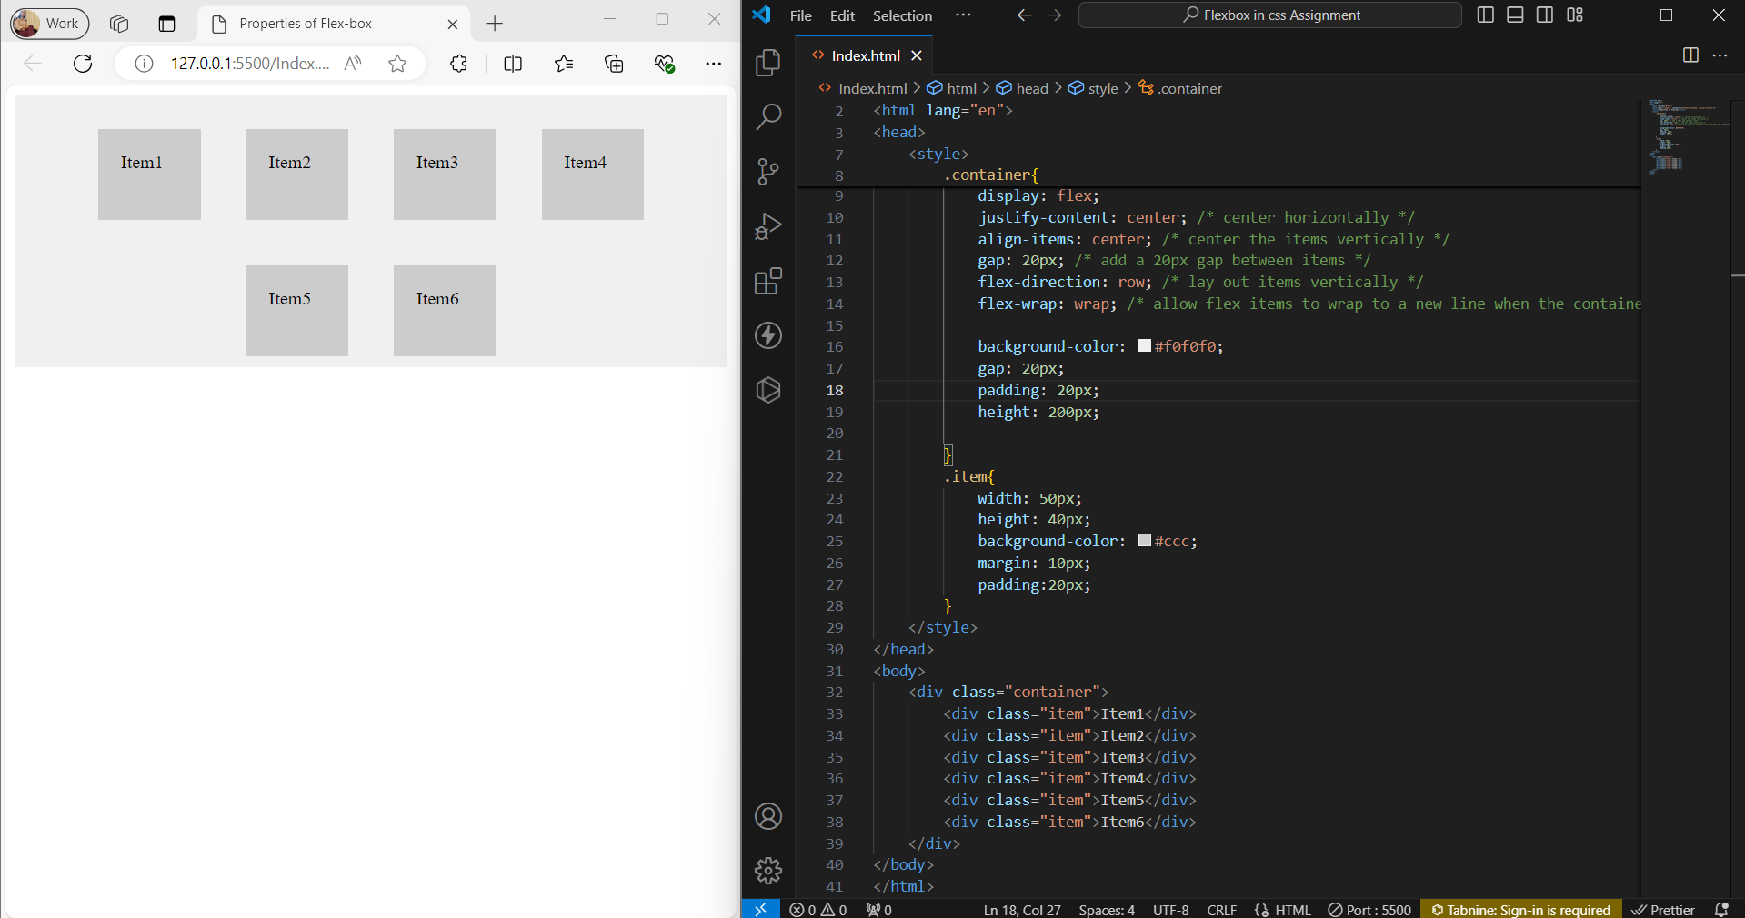

3. Write the code to center a div using CSS Flexbox.

<!DOCTYPE html>

<html lang="en">

  <head>

    <meta charset="UTF-8" />

    <meta name="viewport" content="width=device-width, initial-scale=1.0" />

    <title>Flexbox</title>

    <style>

      .container {

        display: flex;

        justify-content: center; /* horizontally center the flex item */

        align-items: center; /* vertically center the flex item */

        height: 300px;

        background-color: #f0f0f0;

      }

      .rectangle {

        width: 180px;

        height: 200px;

        background-color: rgb(71, 255, 47);

      }

    </style>

  </head>

  <body>

    <div>

      <div class="container">

        <div class="rectangle"></div>

      </div>

    </div>

  </body>

</html>

output:  
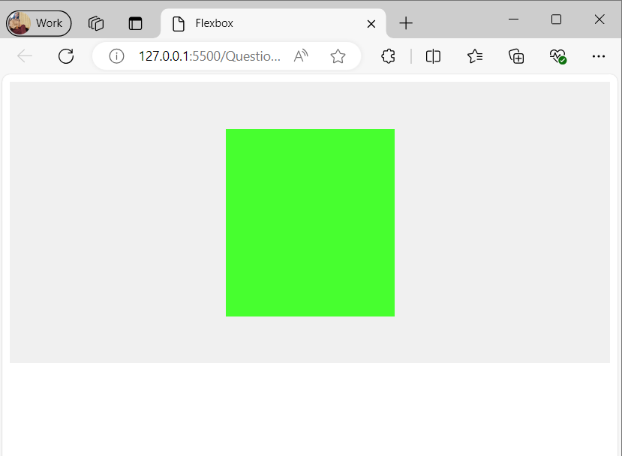

4. A client of yours wants to add a pricing section on their website to showcase their newly introduced premiun plans.You have to build the pricing section for their business. Thay have provided you with the figma design for the same.  
  
<!DOCTYPE html>

<html lang="en">

<head>

    <meta charset="UTF-8">

    <meta name="viewport" content="width=device-width, initial-scale=1.0">

    <title>Document</title>

</head>

<style>

 .container{

    display: flex;

    justify-content: space-between; /* distribute the items evenly */

    flex-wrap: wrap;

    background-color: rgb(248, 235, 248)

 }

 .plan{

    background-color: #fff;

    box-shadow: 0px 0px 10px rgba(0, 0, 0, 0.8);

    border-radius: 10px;

    padding: 8px;

    margin:25px;

 }

.plan:nth-child(even) {

  background-color: rgb(183, 181, 181); /* black background for even-numbered boxes */

}

</style>

<body>

    <div class="container">

        <div class="plan">

            <p>

                <p><h2>Free Plan</h2><span>For Personal</span><br><b>$0</b></p>

              <ul >

                <li>1 users</li>

                <li>4 Web mails</li>

                <li>Responsive Website</li>

                <li>Free SSL</li>

            </ul>

        </div>

        <div class="plan">

            <p><h2>Basic Plan</h2><span>For small business</span><br><b>$29</b></p>

            <ul >

                <li>4 users</li>

                <li>10 Web mails</li>

                <li>Responsive Website</li>

                <li>Free SSL</li>

            </ul>

        </div>

        <div class="plan">

            <p><h2>Pro Plan</h2><span>For enterprise</span><br><b>$49</b></p>

            <ul >

                <li>Unlimited users</li>

                <li>Unlimited Web mails</li>

                <li>Responsive Website</li>

                <li>Free SSL + SEO</li>

            </ul>

        </div>

    </div>

</body>

</html>

output:

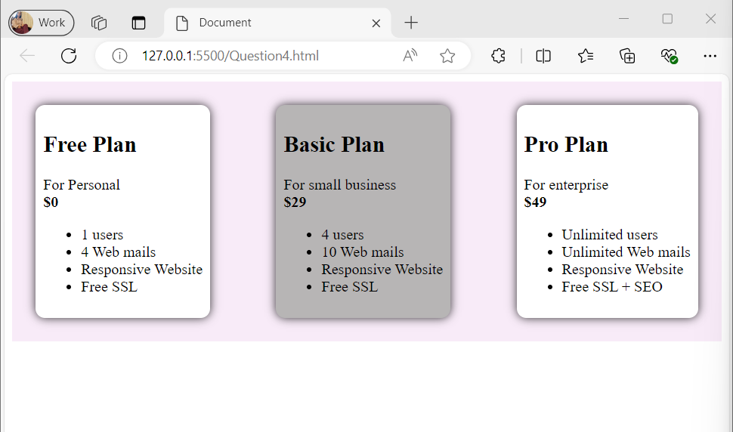  
  
  
  
5. Build a clone of the IRCTC Ticket booking page.

<!DOCTYPE html>

<html lang="en">

<head>

    <meta charset="UTF-8" />

    <meta name="viewport" content="width=device-width, initial-scale=1.0" />

    <title>Irctc</title>

    <link rel="stylesheet" href="https://cdnjs.cloudflare.com/ajax/libs/font-awesome/5.15.3/css/all.min.css" />

   <link rel="stylesheet" href="Question5.css">

</head>

<body>

    <div class="container">

        <div class="half">

            <table class="formClass">

                <tr>

                    <td rowspan="2" class="tdWidth">

                        <div class="irctcImg">

                            <img src="https://logos-world.net/wp-content/uploads/2020/11/IRCTC-Emblem-700x394.png"

                                height="100" width="100" />

                            <img src="https://i.pinimg.com/originals/6a/72/4b/6a724b9501764fd83a4abcd37b58144d.png"

                                height="50" width="50" />

                        </div>

                    </td>

                    <td>Ask Dish&nbsp;&nbsp;&nbsp;Contact-us&nbsp;&nbsp;&nbsp;Alerts</td>

                </tr>

                <tr>

                    <td><button>Login</button>

                        <button>Register</button>

                        <button>AgentLogin</button>

                    </td>

                </tr>

            </table>

            <div class="DivContainer">

                <form action="">

                    <h1>Indian Railways</h1>

                    <span style="color: green;">Safety</span>

                    <span style="color: orange;">Security</span>

                    <span style="color: gray;">Punctuality</span><br><br><br>

                    <button style="background-color: rgb(114, 114, 244);">BOOK Ticket</button>

                    <button><i class="fas fa-check"></i></i>PNR Status</button>

                    <button><i class="fas fa-calendar"></i> Charts/ Vabant</button><br><br><br>

                    <div class="table-container">

                        <div class="table-wrapper">

                            <table>

                                <tr>

                                    <td rowspan="3"><i class="fa fa-train fa-lg"></i></td>

                                    <td><select class="selectClass">

                                            <option value="">From</option>

                                            <option value="">Bangalore</option>

                                        </select>

                                    </td>

                                </tr>

                                <tr>

                                    <td><b>Bangalore</b></td>

                                </tr>

                                <tr>

                                    <td>KSR - Bangalore</td>

                                </tr>

                            </table>

                            <i class="fa fa-arrows-alt-h"></i><br><br>

                        </div>

                        <table>

                            <tr>

                                <td rowspan="3"><i class="fa fa-train fa-lg"></i></td>

                                <td><select class="selectClass">

                                        <option value="">To</option>

                                        <option value="">Kasaragod</option>

                                    </select>

                                </td>

                            </tr>

                            <tr>

                                <td><b>Kasaragod</b></td>

                            </tr>

                            <tr>

                                <td>KSD - Kasaragod</td>

                            </tr>

                        </table>

                    </div><br>

                    <div class="table-container">

                        <div class="table-wrapper">

                            <table>

                                <tr>

                                    <td rowspan="3"><i class="fa fa-train fa-lg"></i></td>

                                    <td><select class="selectClass">

                                            <option value="">Date</option>

                                            <option value="">01 Aug 23</option>

                                        </select>

                                    </td>

                                </tr>

                                <tr>

                                    <td><b>01 Aug 23</b></td>

                                </tr>

                                <tr>

                                    <td>Tuesday</td>

                                </tr>

                            </table>

                            <table>

                                <tr>

                                    <td rowspan="3"><i class="fa fa-adjust fa-lg"></i></td>

                                    <td><select class="selectClass">

                                            <option value="">Class</option>

                                            <option value="">3A</option>

                                        </select>

                                    </td>

                                </tr>

                                <tr>

                                    <td><b>3A</b></td>

                                </tr>

                                <tr>

                                    <td>AC 3 Tier</td>

                                </tr>

                            </table>

                        </div>

                        <table>

                            <tr>

                                <td rowspan="3"><i class="fa fa-window-restore"></i></td>

                                <td><select class="selectClass">

                                        <option value="">Seat Type</option>

                                        <option value="">TATKAL</option>

                                    </select>

                                </td>

                            </tr>

                            <tr>

                                <td><b>TATKAL</b></td>

                            </tr>

                            <tr>

                                <td>AC 3 Tier</td>

                            </tr>

                        </table>

                    </div><br><br>

                    <button type="submit"

                        class="searchBtn">

                        Search train <i class="fa fa-arrow-right"></i>

                    </button>

                </form>

            </div>

        </div>

        <div class="full" style="display: block;">

            <img class="irctcImg"

                src="https://images.unsplash.com/photo-1691352304589-f4d2e5bc9375?q=80&w=1974&auto=format&fit=crop&ixlib=rb-4.0.3&ixid=M3wxMjA3fDB8MHxwaG90by1wYWdlfHx8fGVufDB8fHx8fA%3D%3D"

                 />

        </div>

    </div>

</body>

</html>

css code-

.container {

  display: flex;

}

.half {

  flex-basis: 50%;

  /* set the initial width to 50% */

}

.half img {

  max-width: 100%;

  height: auto;

  display: block;

}

#testnav {

  display: flex;

  list-style-type: none;

  padding: 0;

  margin: 0;

}

.nav {

  height: 10%;

  width: 20%;

  display: flex;

  justify-content: space-between;

  margin: 10px;

  padding: 10px;

}

.navright {

  display: flex;

  list-style-type: none;

}

.navn {

  display: none;

}

.table-container {

  display: flex;

  flex-wrap: wrap;

  border-style: solid;

  border-color: rgb(215, 212, 212);

}

.table-container table {

  margin: 10px;

}

table {

  padding-left: 50px;

}

.table-wrapper {

  display: flex;

  align-items: center;

}

.table-wrapper i {

  margin: 0 10px;

}

.irctcImg {

  height: 120%;

  width: 100%;

}

.formClass {

  width: 100%;

  table-layout: fixed;

}

.tdWidth {

  width: 70%;

}

.irctcImg {

  display: flex;

  justify-content: flex-start;

  margin-right: 50px;

}

.DivContainer {

  text-align: left;

  margin: 80px 60px 0px 60px;

}

.searchBtn {

  background-color: #2ecc71;

  font-size: 16px;

  color: #ffffff;

  border: none;

  width: 650px;

  height: 45px;

}

.selectClass {

  border: none;

}

output:-  
  
